GIT
GIT: Global Information Tracker
Checking whether git installed or not using
Git –version
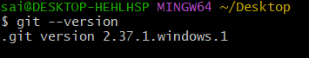
Creating a directory called (hiring application) on windows for having a source code
Open visual studio code or vs code from it and write the code
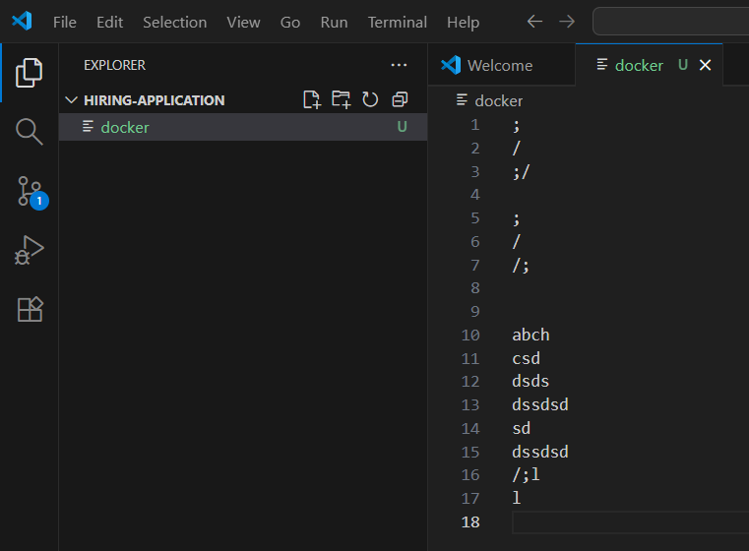
Change the directory to hiring-application and listing files
Cd hiring-application
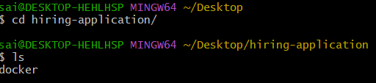
Checking git status and long listing the files in it to see hidden files
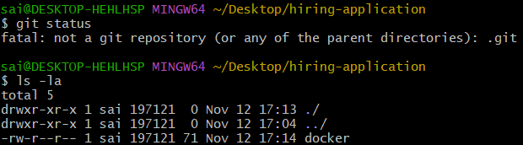
Initialising git using git init
Changing the directory to git and listing the files (configurations)
Using cd .git/
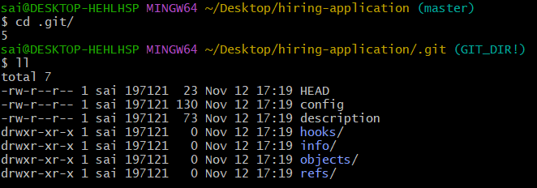
Going to last directory or one step back using cd ..
And listed the hidden files using ls-a
And listing git status checking the tracked or untracked files
And git started to track files after initializing git
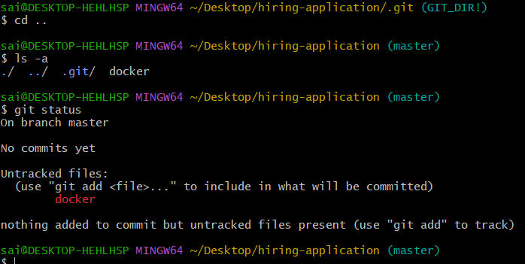

Created a file using touch command and testing whether git is tracking or not
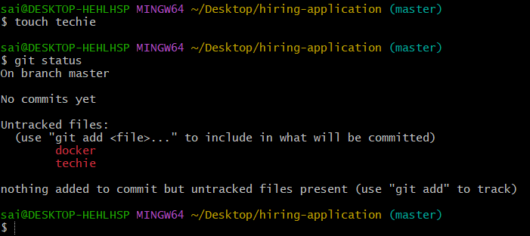
With out .git/ directory git will not work
Deleted .git/ directory using rm -rf command and checked git status
Later again initialized git to get deleted directory
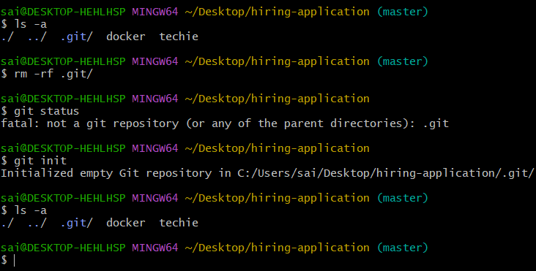
Checked the git status again to verify
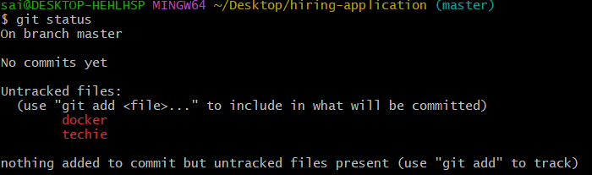
To fetch the details we use command git config –list
But in the below output we are unable to see username and email of the author
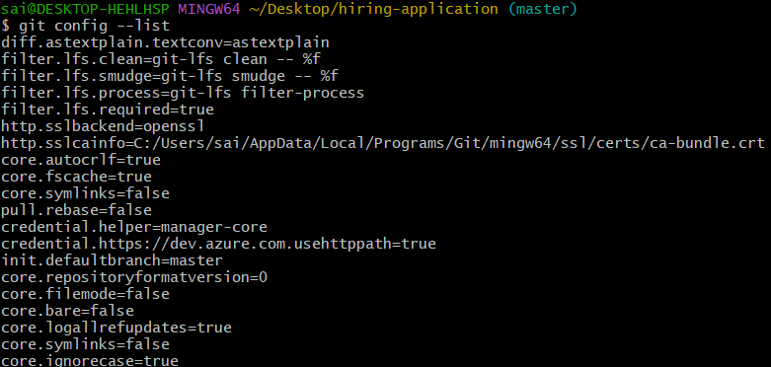

Added user name and email id using
Command : git config --global user.name ‘name’ for adding name
: git config --global user.email ‘email id’ for adding email id
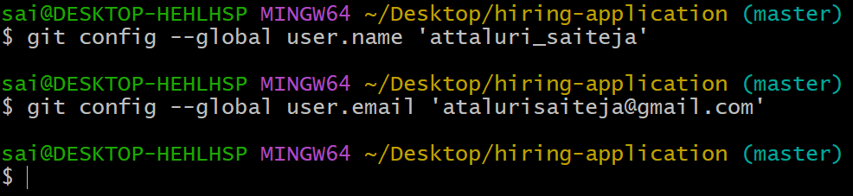

Using git config --list
To verify whether listed or not
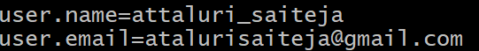
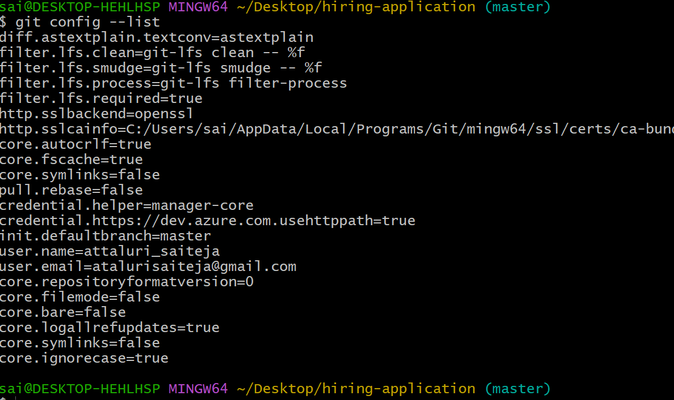
Checked git status again and added to tracked files using git add . command
( “.” Means all files) or else git add techie docker etc
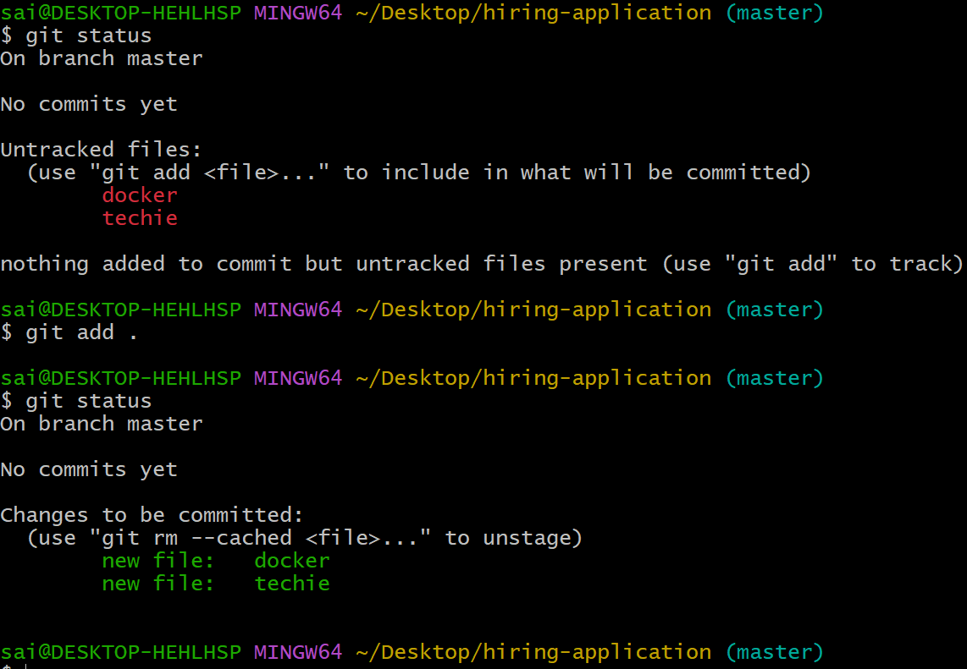

Created multiple files using touch and checking git status whether tracked or not
Earlier added files got to tracked and latest files are not in track so use git add . command to add all at once or else need to add one by one by entering all file names
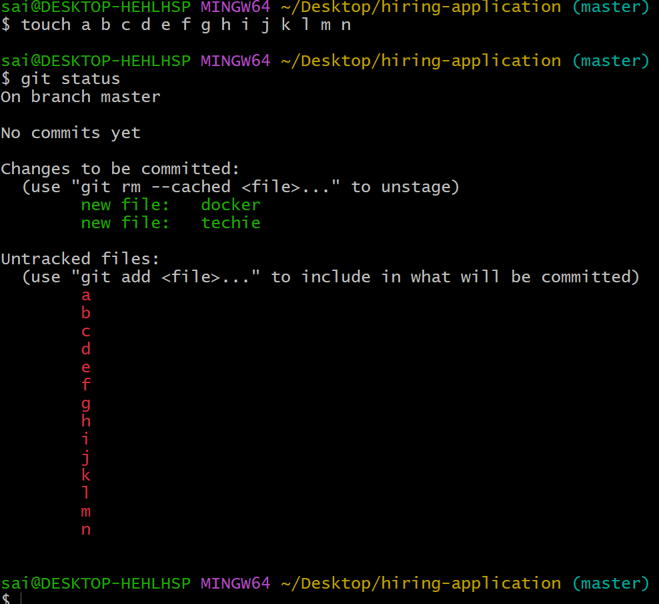
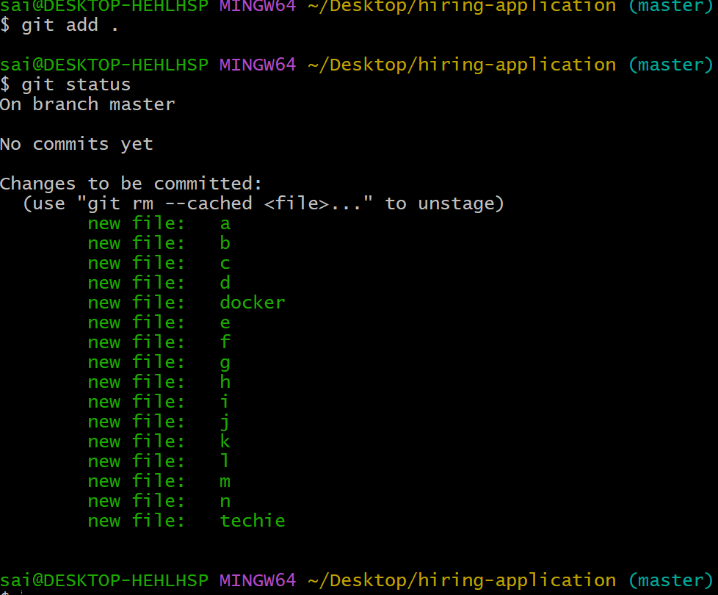
Command :git commit
It will store a copy in our machine and track the changes you have committed
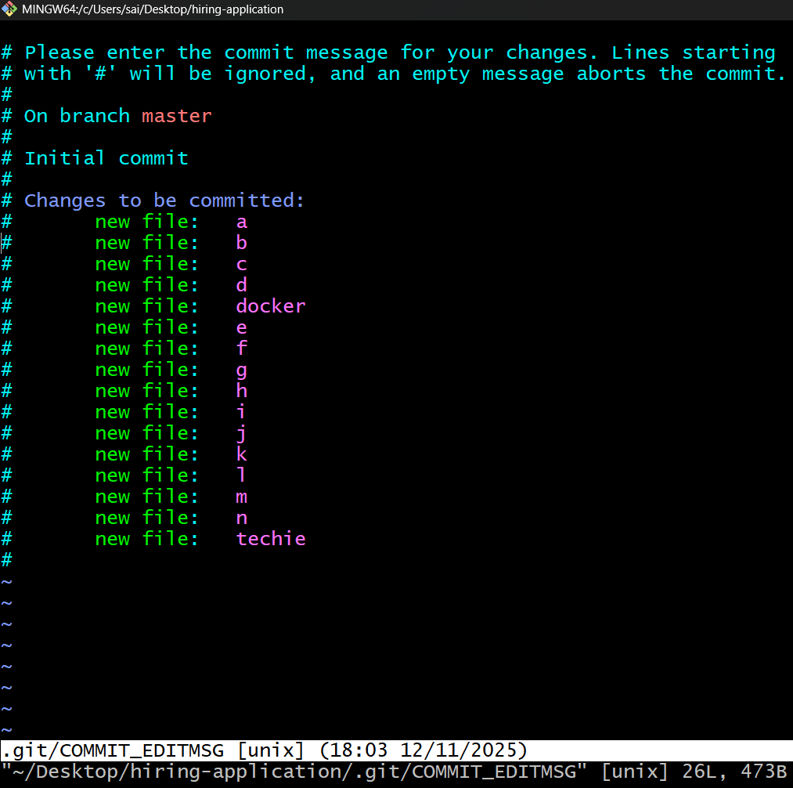

Using git commit -m “ messages ”
In “messages” give a relavant message for knowing what changes or commits done for
Ex git commit -m “added new couple of files”
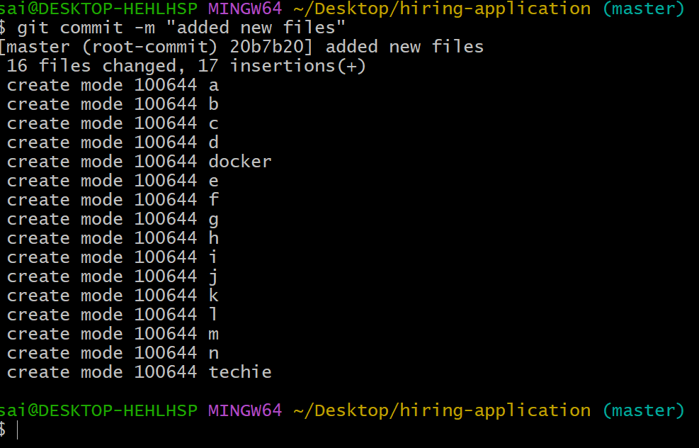

Checking status again to track files all are tracked or not to push local server into central repository
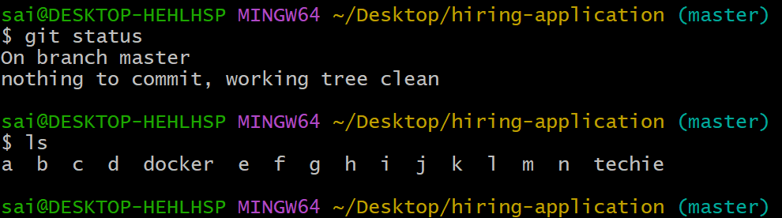
To see commit id we use command : git log (print all the logs which we committed)
Commit number starting with 20b7b………
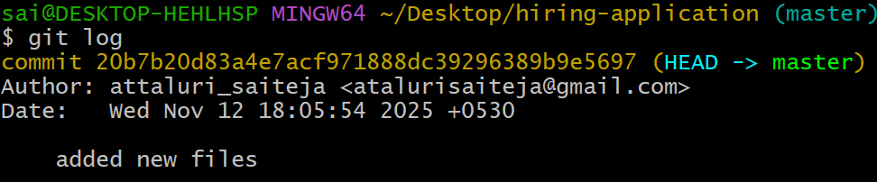
Created new files, and checked the status, added to tracked files and ,given messages using git commit and checked logs (here we can see multiple logs because of multiple activity we had done) we can see multiple commit numbers
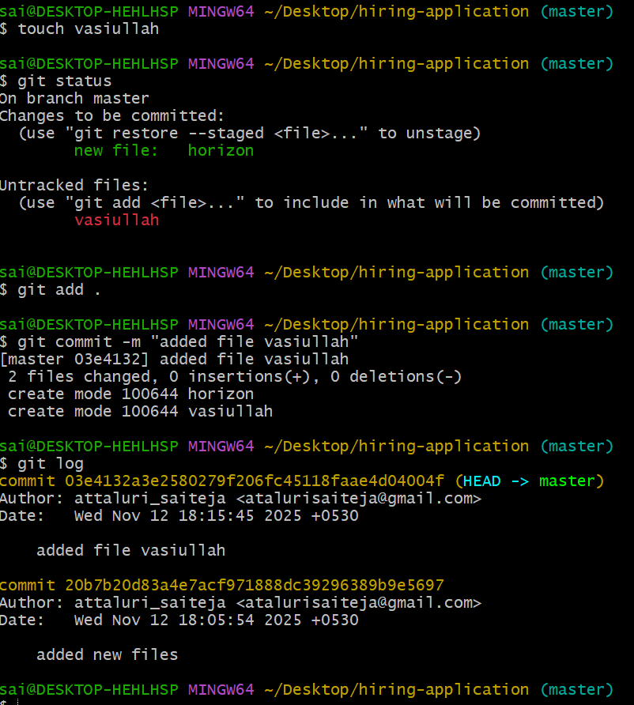
Command git push for pushing files to repository
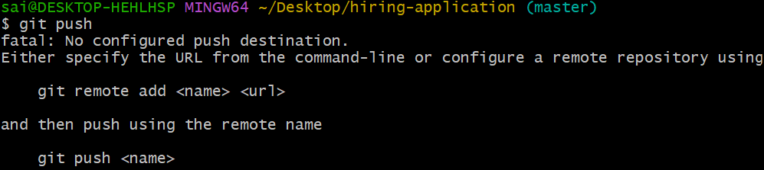
Creating new repository in github
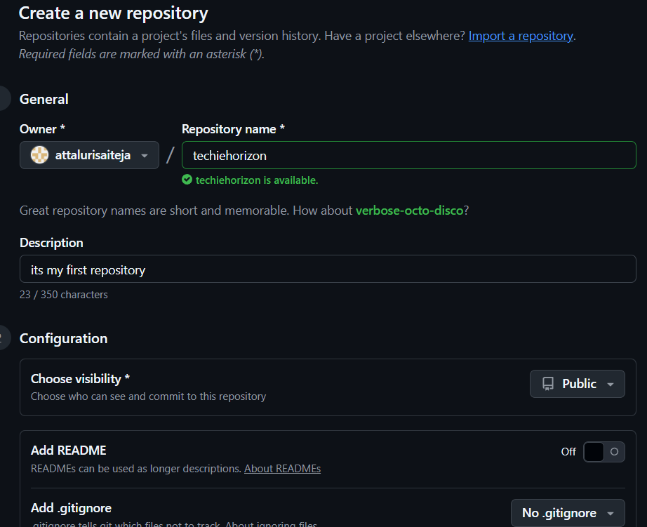
And using command to add name and ssh link
Git remote add name link
Command git remote -v for checking addresses available or not
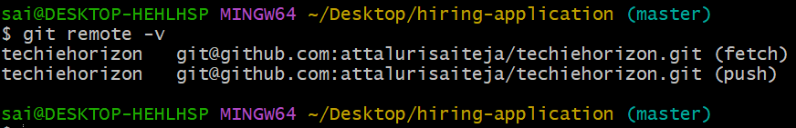

Generating key using ssh-keygen
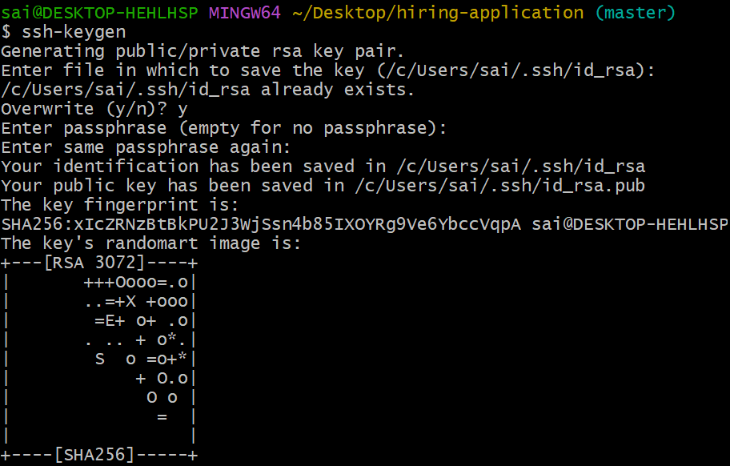
Copying the ssh key and pasting in github

Use command git remote set-url origin sshlink
To give access rights to repository
Ssh link you will get from github page
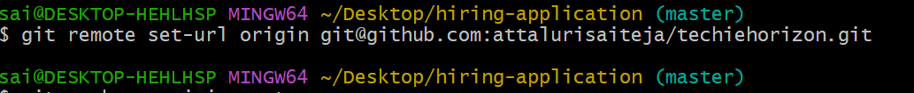

Then push the code or file to github
Command git push -u origin master
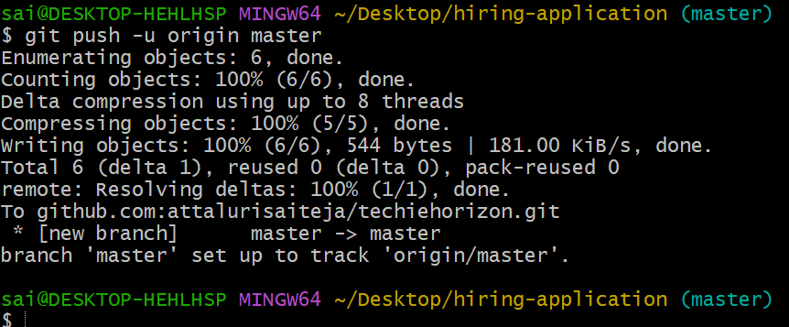
Files got displaying in github website or repository
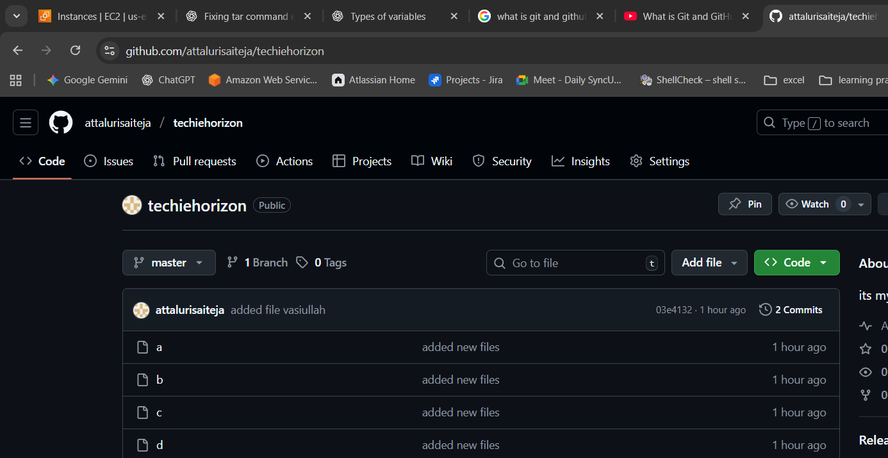

Removed a file called docker and listed the files (that got deleted in local machine) not in repository again checked the status and pushed the files to repository then it got deleted in repository also
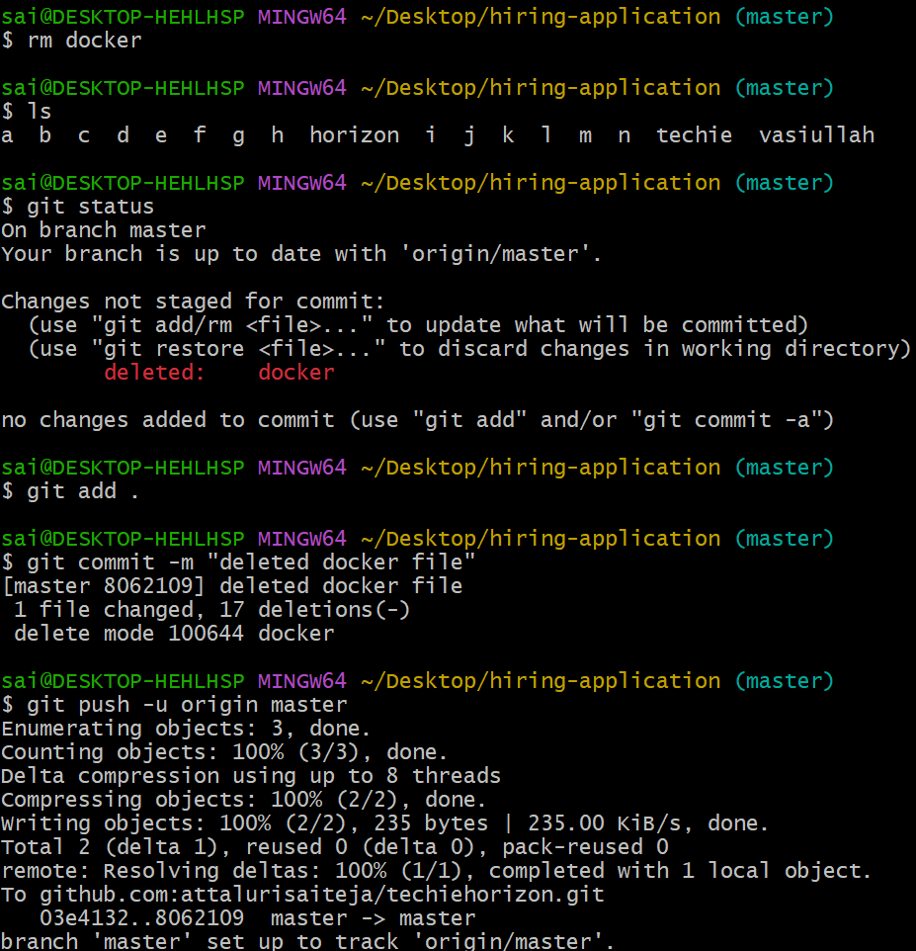

New file created on repository


Using git pull command to get data from repository to local machine as you can see saiteja file is listed in below output
While you are getting error while pushing code then your local machine data and remote server data is not matching so read the error or output carefully to process
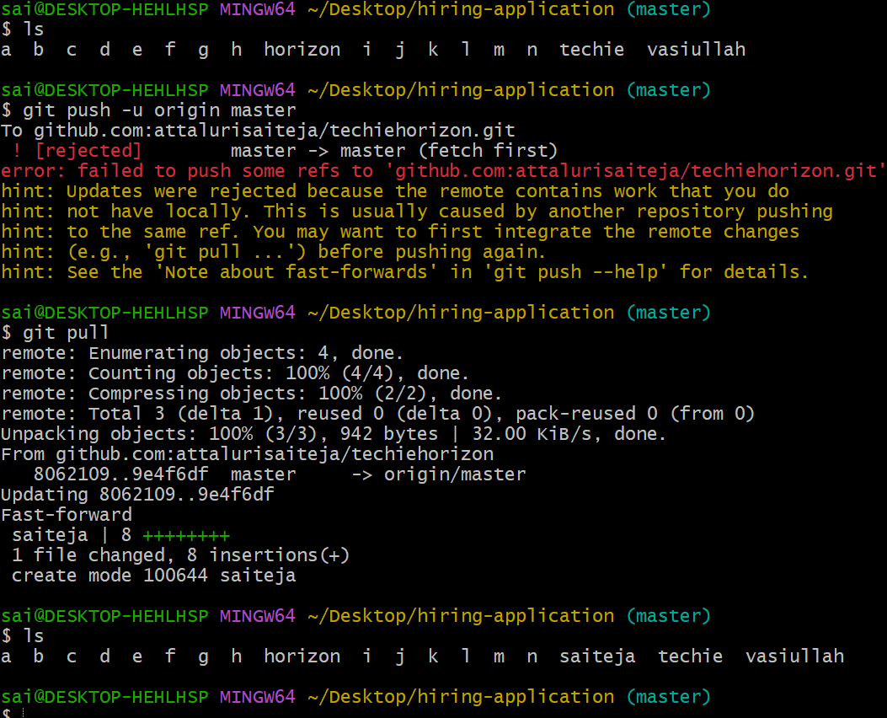
Command git clone to get repository to local machine (help us download the complete repository)
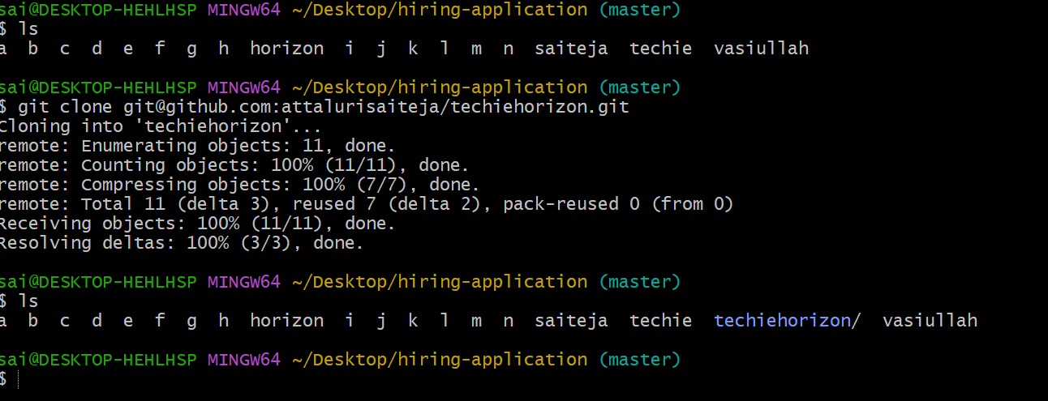
Command git log -2 displays only 2 logs if you need many enter a number or enter git log to get all logs
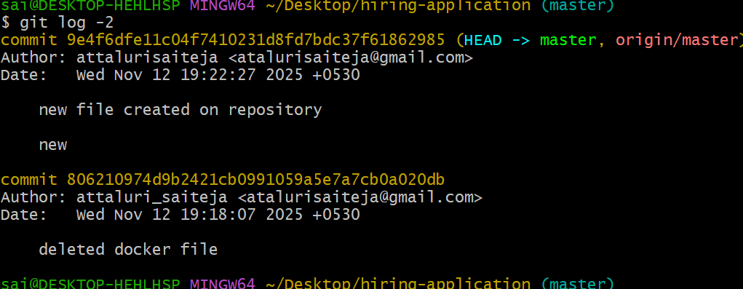
Getting back a deleted file using git revert command
Git revert commit id
